* Cassandra is column oriented database (COD).
* RDBMS stores everything as row based.
* In COD all columns are indexed based on needs. In a 10 column table only 2 or 3 columns are indexed. In solar or Elastic Search all columns are indexed.
* In a 1 million record, if the 100000 Strings are same it will save huge space and access is fast. Because no duplicate entry exists for the column data.

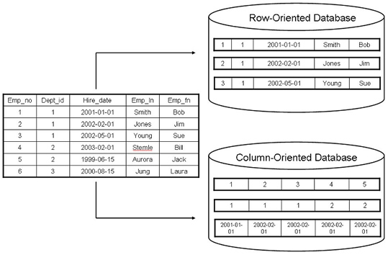

Benefits of column oriented databases:

* High performance on aggregation queries (like COUNT, SUM, AVG, MIN, MAX)
* Highly efficient data compression and/or partitioning
* True scalability and fast data loading for Big Data
* Accessible by many 3rd party BI analytic tools
* Fairly simple systems administration

Column-Oriented Disadvantages

* Transactions are to be avoided or just not supported
* Queries with table joins can reduce high performance
* Record updates and deletes reduce storage efficiency
* Effective partitioning/indexing schemes can be difficult to design

Due to their aggregation capabilities which compute large numbers of similar data items, column oriented databases offer key advantages for certain types of systems, including:

* Data Warehouses and Business Intelligence
* Customer Relationship Management (CRM)